8.24: Let Rebecca’s original direction of motion be the x-direction. a) From conservation of the x-component of momentum,

So 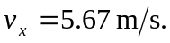 If Rebecca’s final motion is taken to have a positive 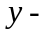component, then

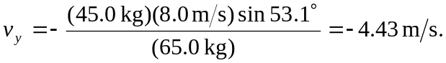

Daniel’s final speed is

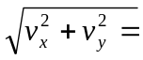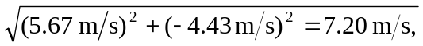

and his direction is arctan 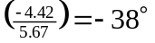 from the axis, which is 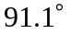 from the direction of Rebecca’s final motion.

b)
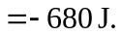

Note that an extra figure was kept in the intermediate calculation.

